Linking SDGs to Taught Courses: Worksheet
The UN Sustainable Development Goals (SDGs) are a major area of focus at De Montfort University across all of the university’s activities.
DMU aims to embed Education for the Sustainable Development Goals (ESDG) across all of its taught programmes. One aspect of this is linking curricula to the SDGs where appropriate. For other aspects, such as developing students’ competencies to act on sustainable development, see here.
The SDGs can be viewed at several levels of detail:
- The overall purpose of Sustainable Development, to meet “the needs of the present without compromising the ability of future generations to meet their own needs” (Brundtland, 1987)
- The 17 specific goals, such as eliminating poverty (SDG#1) or reducing inequalities (SDG#10)
- Specific measurable Targets (x169) and Indicators (x232) associated with the goals (see UN, 2018)
This tool aims to enable structured engagement with the question of how to embed the SDGs in taught courses via some short questions and a template for noting answers. Before trying out the tool, it is worthwhile to familiarise yourself with the SDGs, and Education for the Sustainable Development Goals.
This tool is a pilot resource developed by DMU’s Education for Sustainable Development Forum, as part of a project to enable programmes to enhance linkages to sustainable development. Feedback and suggested improvements to the tool are welcome – please email sustainability@dmu.ac.uk
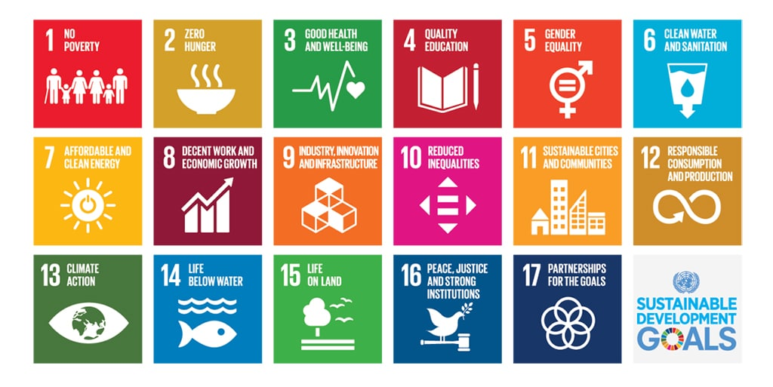

Q1: Reflection: How are the SDGs relevant to your course, and how might their inclusion enhance or change the experience of students taking the course?

Q2: How are the SDGs currently embedded in the course?
For each level of analysis, it can be useful to consider: Intended Learning Outcomes; Course Materials; Learning Activities; Assessment. Links to the SDGs might also be Explicit (E) or Implicit (I) – for example, a session on poverty links to SDG#1 implicitly if it does not explicitly mention the SDG.
Overall focus on Sustainable Development
Coverage of specific SDGs
Contribution to specific Targets / Indicators

Q3: What opportunities exist to enhance how SDGs are embedded in the course?
Use this question to brainstorm ideas before prioritising later (Q5). You could consider:
- Levels of understanding the SDGs (as above): as a whole; as individual SDGs; as Targets/Indicators
- Type of opportunity: Making implicit connections explicit; or additions/changes to curriculum.
Intended Learning Outcomes
Course Materials and Learning Activities
Assessment

Q4: What other ideas has thinking about links to the SDGs given you?
For example, constraints that may limit or delay changes; ideas that may apply to other areas of your work or colleagues’ work.

Q5: Based upon this reflection, what will you do in the future to embed the SDGs in your course?
Try using MoSCoW (Must; Should; Could; Won’t) to prioritise your ideas. For ideas worth pursuing, you could label as This Year (TY) or Later (L). For ideas you won’t pursue, you could note a brief reason in brackets.
Must
Should
Could
Won't

References
Brundtland, G., (1987). Our common future: Report of the 1987 World Commission on Environment and Development. United Nations, Oslo, 1, p.59.
UN (2018) Sustainable Development Goals. https://sustainabledevelopment.un.org/sdgs

