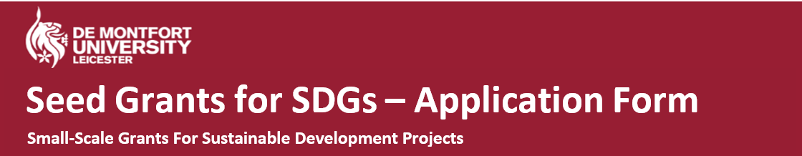Please read Guidance before completing this form, available here: https://esdg.our.dmu.ac.uk/projects/seed-grants-for-sdgs or from contacting sustainability@dmu.ac.uk. Completed applications should be emailed to sustainability@dmu.ac.uk by 11:59am on 26th November 2021 for round 1 applications and 11:59am on 28th January 2022 for round 2 applications.

Name of project:
Organisation (or Team/ Society/etc.) (if applicable)
Lead Applicant:
Name:
Status (please tick) |  | DMU Student |  | DMU Staff |  |  | DMU Alumnus
DMU Role (staff) or DMU Course (student/alumnus)
E-mail:
Telephone Number:
Other Applicant(s):
Name and/or Organisation (if applicable)
Project summary (up to 250 words): Summarise what you plan to do and why. Please also address how the project contributes to the SDGs or sustainable development (including which particular SDG(s) if applicable); how you will evaluate if the project is successful; how you plan to document and disseminate what happens.
Project details:
When will the project take place? (Give specific dates if applicable)
Amount requested
(Not exceeding £1,000):
Please provide an itemised breakdown of what the grant will be spent on (please provide as much detail as possible)
Applicant declaration:
I, the undersigned applicant, hereby confirm that the information contained in this application (including in any documents submitted) is true and correct. I will inform the Seed Grants Panel if any information in this application has changed. For projects involving research, I have already (or will obtain) ethical approval from the relevant DMU committee.

Print name: |  |  |  |  | Signature: (name in ALL CAPS or signature image)
Date:

The following section is not to be filled in by the applicant:
Grant Panel Decision:
This application has been (tick): | Approved |  | Declined
If approved, amount awarded:
Signature of Grant Panel member: |  |  | Date:
Comments and feedback from the Grant Panel:
sustainability@dmu.ac.uk @sustainableDMU

