Example statements of engagement with Sustainability and the SDGs
Version 1, May 2023
Contents
ADH 1
Fashion and Textiles 1
Interior Design 1
Art, Design and Architecture 1
Humanities Programmes 2
CEM 3
School of Computer Science and Informatics 3
School of Engineering and Sustainable Development 3
BAL 4
HLS 4
Policing 4

ADH

Fashion and Textiles
Content: The ethos of responsible design and the relevant UN Sustainable Development Goals will be reflected in this module. Assessment notes: In these assessments, students will be expected to reflect on an ethos of responsible design and where possible the appropriate United Nation’s Sustainable Development Goals.

Interior Design
Within the Interior Design programme, students are introduced to the importance of sustainability and the SDG’s at level 4 in the form of a lecture/seminar activity, this is further enhanced by a designated workshop delivered by industry suppliers of interior design materials who provide knowledge and expertise in specifying ethical materials which have a low impact on the environment. At level 5 and 6 students build on this knowledge and awareness as they tackle more complex projects ensuring that sustainability is very much part of their design decision making.

Art, Design and Architecture
Within ADA sustainability is embedded into all programmes as an attitude rather than a solution. This attitude has been evolving within the field of architecture and design since the 1970s. To use John Elkington’s ‘triple bottom line’ we define sustainability as the integration of social, economic, and environmental values and teach the consideration of these in all aspects of design education, alongside asking students to consider the consequences of their design proposals on society and the environment. This attitude is intrinsic to design thinking and is essential knowledge for professional success. Examples of sustainability can be found in every module throughout the School, whether in response to ethical choice of materials or environmental, or contextual / situated learning, or teaching social responsibility and user centric design with a focus on inclusivity, accessibility, gender based, cultural sensitivity. Students are taught to think about scarcity and abundance, longevity of product/artefact, reuse, retrofit and whether sustainable development and design or artwork is even possible in every project. A broad approach in addressing UN SDGS and an awareness of their impact, is layered into all module.

ADA has set up a cross programme working group, ‘The Future We Want’ to evolve and share good practice when embedding sustainability, SDGs, Resilience, mitigation, adaptation, net zero etc. ADA also has a working group ‘ Stuff and Things’ to particularly look at The circular economy / ethical material culture /waste reduction.

Humanities Programmes
A note on sustainability, and the UN’s Sustainable Development Goals. The contribution of a single degree programme, or cluster of programmes, towards the UN SDGs may seem to be negligible when compared with issues of protection/conservation of natural resources, reducing fuel use, and general environmentally friendly policies, which are operationalised at institutional level. We would, however, argue that our subjects play a role towards the achievement of several SDGs, both directly and indirectly:
Quality education - "Ensure inclusive and equitable quality education and promote lifelong learning opportunities for all".
Gender equality - "Achieve gender equality and empower all women and girls".

Peace, justice and strong institutions - "Promote peaceful and inclusive societies for sustainable development, provide access to justice for all and build effective, accountable and inclusive institutions at all levels".
Goal 11.4 - "Strengthen efforts to protect and safeguard the world’s cultural and natural heritage"
‘Environment’ as a concept is not simply about the physical world. The geosphere and biosphere are merely two elements; we must remember de Chardin and Vernadsky’s concept of the ‘noosphere’, the complex network of beliefs, ideals, ideologies and faiths which form humanity’s mental heritage. As a university, we are centrally concerned with the preservation and development of the noosphere; we are champions of nootic sustainability. Our students engage with questions of diversity, and the challenges involved in the recording, preservation, and revitalisation of threatened, moribund, and lesser-used languages, literatures and histories. A central element therefore, of studying all degrees involving humanities, is deepening an awareness and appreciation of the cultural.
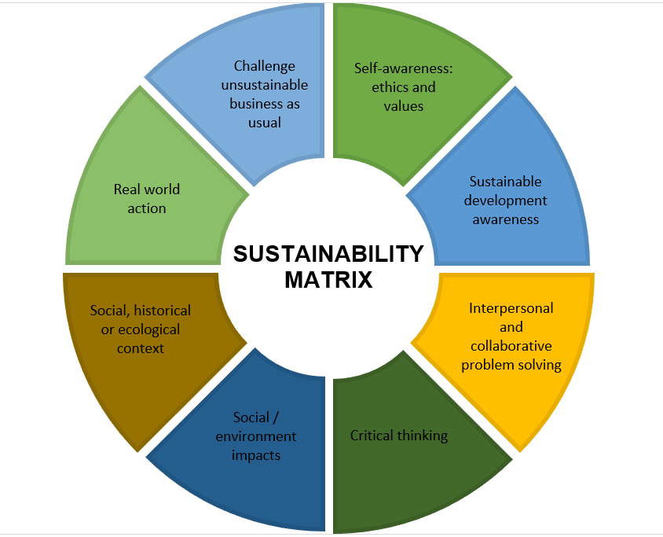
Our courses directly address many aspects of the Sustainability Matrix, shown below. What has already been illustrated in this document, in terms of course content and teaching, learning and assessment strategies, exemplifies engagement with interpersonal and collaborative problem solving, self-awareness, ethics and values, critical thinking and social and historical context. A DMU Humanities student is challenged to engage with the past, present and future through their own lived experience, and develop their critical voices as

CEM

School of Computer Science and Informatics
School-level:
Our curriculum is informed by the on-going excellent research carried out within the School. Of particular note, the Centre for Computing and Social Responsibility are particularly influential in delivering subject material that relates to ethics and associated areas (including sustainability). As can be seen in the new Programme, there is a significant theme of ethics throughout the course, and this provides further opportunities to explore sustainability. ICT for Development for example includes consideration of the digital divide (economic, social, political, cultural, etc.) in relation to both issues and solutions, and includes consideration of the UN SDG’s.
Programme-level:
This programme engages with ethical, social, and environmental sustainability through input and modules led by members of the Centre for Computing & Social Responsibility, a leading research centre in this field. Cutting edge research from the CCSR (Centre of Computing and Social Responsibility) including responsible research and innovation, ethical and social impact of technology, and in the area of the UN (United Nations) Sustainable Development Goals are embedded in a broad range of teaching across the programme. Systems thinking, ICT for development, and the embedding of ethics into the final year projects are some examples of this integration.

School of Engineering and Sustainable Development
Within DMU’s School of Engineering and Sustainable Development our focus in taught programmes is on using the professional skills of engineering to address many of the world’s contemporary sustainable development challenges, such as designing renewable energy systems and providing electric vehicle infrastructure.
Our engineering programmes are accredited by the IET (Institution of Engineering Technology) AND IMEchE (INSTITUTE OF MECHANICAL ENGINEERS) and as a result, are designed to promote sustainable development and to develop engineers who consider the environmental and sustainability-related constraints within design projects.
A key strength of the school is our engagement with real-world projects and challenges. Engineering students have participated for many years in the Engineering for People design challenge, run with the NGO ‘Engineers without Borders’. Through the competition, groups of students on the 2nd year Project Management module develop engineering-based solutions for specific sustainable development challenges in overseas communities. Past projects have included topics such as rainwater harvesting and access to sanitation facilities. DMU students have been finalists every year since 2014.
In addition teams of DMU students can engage with the ‘Formula Student’ competition through which they develop a car for racing against other student teams from UK universities. The competition has recently switched over to all-electric vehicles, providing valuable learning opportunities around the technical issues involved in transitioning to electric cars and vans to help address climate change.
At Masters level, the school has been running sector-leading Masters programmes for several decades addressing practical solutions to sustainable energy, energy efficient buildings and sustainable lifestyles with students from all over the world. In recent years, the school’s programmes in Engineering Management and Energy Engineering have forged important links between the core skills of engineering and the key professions in which engineering insight is required to address the sustainable development agenda.
Overall, as the school’s name suggests, sustainable development is at the heart of how engineering is taught, with the aim of developing graduates well-placed to design the sustainable systems of the future.

BAL
BAL has adopted the common Programme Learning Outcome across every programme without exception:
Develop and apply values, skills, knowledge and behaviours that will enable them to contribute to the development of a just, peaceful and sustainable world.

HLS

Policing
Within DMU’s Policing and Criminal Investigations team taught programmes, there is a focus on Sustainable Development issues, covering a number of areas of the United Nations Sustainability Goals (2030). This includes providing students with a level of education which makes explicit links to inclusivity, equality and continual professional development in response to a contemporary changing landscape of challenges. This involves an understanding of both internal and external cultural dimensions, along with a range of differing views and perspectives in others.
The programmes focus on ensuring a range of teaching styles and assessments which link real world experience to taught material and learning. There is an emphasis on individual practitioner competencies and ability to view issues with an appropriate level of complexity and understanding. Weight is put the consideration of the individual practitioner’s wellbeing, and on their understanding and consideration of vulnerability and safeguarding as regarding engagement and needs of the public.
The programmes look to develop students with the knowledge, understanding and professional skills of investigation and policing, and be able to understand many of the world’s contemporary sustainable development challenges, such as building trust, legitimacy, ethical practice and strong justice institutions. Insodoing, the programme addresses UNESCO’s cross-cutting competencies for working on sustainable development highlighted in the AdvanceHE/QAA (2021) guidance on Education for Sustainable Development in Higher Education.
The Professional Policing degree programme is accredited by the College of Policing and this informs and directly influences the Criminal Investigation & Policing Studies programme, with a strong ethos base of equality and the just use of legal powers relative to citizens, groups and the wider community. This develops practitioners who are able to apply their operational discretion in the best interests of legitimacy, public trust and fairness.
The programmes influenced by the College of Policing seek to provide students with the competencies to be autonomy practitioners who can engage with the citizen, groups and the community in a lawful, unbiased, fair and equitable way, in a way which considers and reduces inequality.

