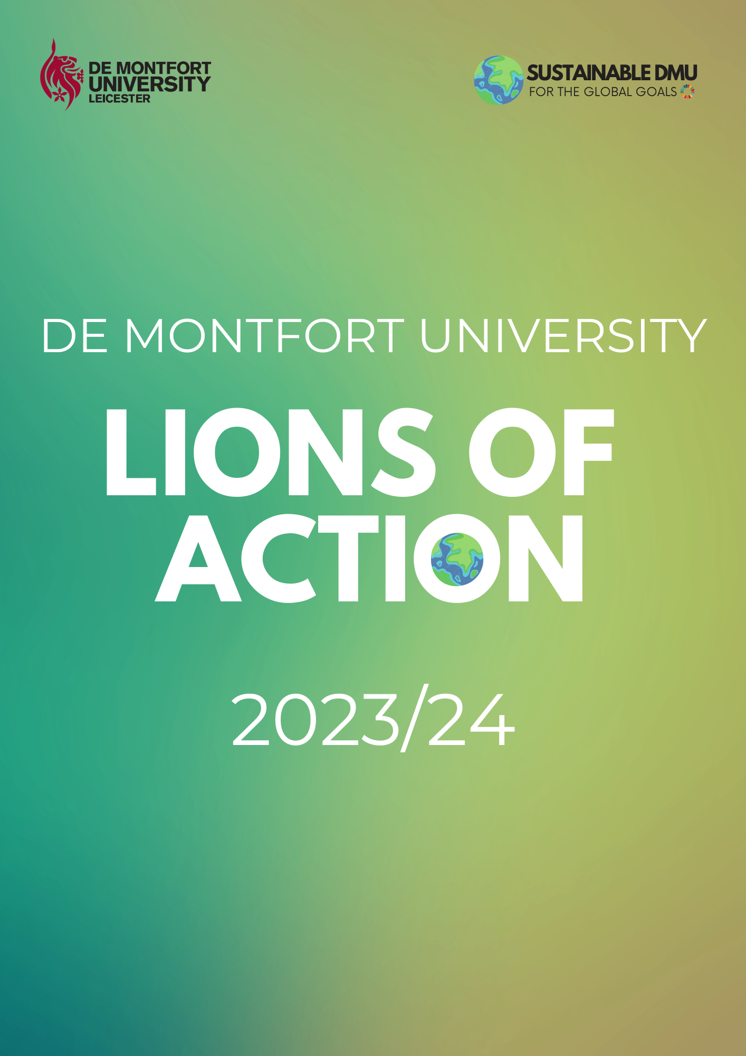
WELCOME TO LIONS OF ACTION

What is ‘Lions of Action’?
Lions of Action is a sustainability competition for societies and sport clubs. It is a creative and rewarding way for you to get inspiration and recognition for building sustainability on the De Montfort University Campus. The project is an adaption of the ‘Greener Futures’ imitative at the University of West Bristol.
The prizes for winning are £500 for first place and £250 for second place in funding for your club or society. Additionally, at the end of the academic year, the club or society that has shown commitment and creativity in its approach to sustainability will receive the Climate Action Champion of the Year Award. Clubs can also receive additional awards such as the First Step Award and Most Improved Award.

How can my society/club participate?
To sign your club or society up by completing the online application form here. Then to get started the contact person for the society or club will join the Lions of Action Teams Channel. Every time you complete a challenge, found in this workbook, upload evidence to the channel and your points will be added. At the end of April (23rd) 2024, you could build up enough points to win the main prize. For each challenge you upload to social media, please tag the Sustainability Team (@sustainabledmu) and the hashtag with the number of the challenge e.g, #LionsOfAction1 or #LionsOfAction2. Also make it clear which club or society you are part of when uploading evidence to the channel so we can make sure you get the points.
You can apply for the SeeD Grant for the SDGs to fund your activities. You can find more information about the grant here.
Note that the photos you post in the channel may be used on the University’s social media or marketing materials. If you would prefer us not to use your content, please email us at sustainability@dmu.ac.uk.
THE CHALLENGES
The challenges are split into five sections:
- Starting Sustainable
- Get Involved
- Take Action
- Think Big Picture
- Get Creative

For more information about the United Nations Sustainable Development Goals, please visit Take Action for the Sustainable Development Goals.
STARTING SUSTAINABLE
Challenge | Description | Submission of Evidence | Points
#LionsOfAction1 | Elect or assign a Sustainability Officer to represent your club or society. | Submit name and picture of officer in Lions of Action Teams Channel. | 5 points
#LionsOfAction2 | 10 society or club members to follow the Sustainable DMU Instagram. | Email sustainbility@dmu.ac.uk with the username of the followers | 1 point for every follower.
#LionsOfAction3 | Create, organize and implement a sustainability campaign. | Post photos to society or club social media account with a short caption about your experience.  Write an article about your campaign to complete #LionsOfAction4 | 20 points.
#LionsOfAction4 | Produce a news article or blog post with a sustainability theme relating to your society or sports club. | Email article to sustainability@dmu.ac.uk and post link to social media account once published. | 10 points (plus 5 points each time this challenge is repeated)
#LionsOfAction5 | 10 society of club members to follow Sustainable DMU LinkedIn page. | Submit names to Lions of Action Teams Channel. | 1 point for every follower.

GET INVOLVED
Challenge | Description | Submission of Evidence | Points
#LionsOfAction6 | 5 or more members to attend Carbon Literacy Training by ESDG. | Submit names of members in Lions of Action Teams Channel. | 10 points (plus 5 points each time this challenge is repeated)
#LionsOfAction7 | 5 or more members to attend Sustainability Road Pop-Up Roadshow. | Submit photos in Lions of Action Teams Channel. | 10 points (plus 5 points each time this challenge is repeated)
#LionsOfAction8 | Run a collaborative sustainability event with another society/club or local organization. | Post photos to society/club social media account with short caption about experience. Submit link to post in Lions of Action Teams Channel.  Write an article about your campaign to complete #LionsOfAction4 | 20 points per event
#LionsOfAction9 | 5 or more members to attend a Liberation Campaign event (Black History Month, LGBT+ History Month, International Women’s Week etc) | Post photos to society/club social media account with short caption about experience. Submit link to post in Lions of Action Teams Channel.  Write an article about your campaign to complete #LionsOfAction4 | 10 points (plus 5 points each time this challenge is repeated)
#LionsOfAction10 | Hedgehog Protection.  Participate in a hedgehog litter pick on campus. | Submit pictures of litter pick to Lions of Action Teams Channel. | 10 points

TAKE ACTION
Challenge | Description | Submission of Evidence | Points
#LionsOfAction11 | 5 members of your society or club to go meat-free for lunch or dinner for one week. | Post photos to social media account with caption about experience. Post link in the Lions of Action Teams Channel | 15 points in total for all five members completing the challenge.
#LionsOfAction12 | 2 club or society members to live plastic-free for a day. | Post photos to social media account with caption about experience. Post link in the Lions of Action Teams Channel | 10 points (plus 2 points each time this challenge is repeated)
#LionsOfAction13 | Donate a bag of unwanted clothing to the charity bin located at the Student Union | Post photos to social media account with caption about experience. Post link in the Lions of Action Teams Channel | 1 bag = 5 points  5 bags = 10 points  10+ bags = 15 points
#LionsOfAction14 | Members consistently using re-usable water bottles. | Post photos to social media account. | 5 points
#LionsOfAction15 | 5 or more members actively recycling | Post photos to social media account with caption about experience. Post link in the Lions of Action Teams Channel | 5 points (plus 2 points each time this challenge is repeated)
#LionsOfAction16 | A member of a society used a service such as “Too Good To Go” to prevent food waste | Post photos on social media account about the experience. | 10 points (plus 2 points each time this challenge is repeated)
#LionsOfAction17 | 2 or more members participate in the SDG Teach-in in March 2024 | Submit names of members who participated in Lions of Action Teams Channel. | 5 points (plus 2 points each time this challenge is repeated)

THINK BIG PICTURE
Challenge | Description | Submission of Evidence | Points
#LionsOfAction18 | Calculate your carbon footprint. Devise an action plan for how you can reduce your footprint. | Post photos to social media account with caption about experience. Post link in the Lions of Action Teams Channel | 10 points for every individual member who completes this.
#LionsOfAction19 | Create a Mental Health Awareness campaign for your club or society. Share your tips for looking after your mental health and wellbeing. | You could share this in a blog post for #LionsOfAction4 or post them to your social media accounts. | 10 points for the campaign and 2 points per individual member who shares tips.
#LionsOfAction20 | Club or society members spending time in nature. This can help improve your mental health and appreciation of the environment. | Post photos to social media account with caption about experience. Post link in the Lions of Action Teams Channel | 5 points
#LionsOfAction21 | Find out about the United Nations Sustainable Development Goals in this video. Create a short action plan about how your club or society can contribute to these. You may choose to focus on one or two relevant goals. | Post your plan on your social media account and submit to Lions of Action Teams Channel. | 20 points.

GET CREATIVE
We encourage you to get creative with sustainable living. If you’ve done something you think was a great sustainability action, upload it to the Lions of Action Teams Channel and we’ll give you points (ranging from 5 points to 20 points).

Here’s some ideas of what you could do:
- Try sustainable period products.
- Try a shampoo bar.
- Try sustainable cutlery for a week.
- Volunteer for a local organization or charity.
- Give a cycling route in Leicester a go.
- Watch a film/documentary about sustainability or social justice.

If you have any questions or concerns, please contact the Sustainability Team at sustainability@dmu.ac.uk.
Follow us on our social media accounts @SustainableDMU.

