 

**Sustainable Development Goals (SDG) Advocates**

**Guide 2024/25**

*Version 1: September 8th, 2022*  
*Updated on: January 2nd , 2024*

Contents

QUICKSTART GUIDE 3

LEARN 4

Short Workshops 4

Advocate-organised Sessions 4

Other Learning Activities 4

NETWORK 5

Teams Group and Email List 5

Networking Events 5

CONTRIBUTE 6

Pre-Organised Extra-Curricular Activities 6

Self-Organised Extra-Curricular Activities 6

RECOGNITION 7

Your Learning and Contribution 7

Your Reflection 7

Celebration and Awards 7

THE TEAM 8

FAQ 9

**Welcome!**

Thank you for signing-up to join the SDG Advocates network at DMU!

The programme has been designed to enable our students to make a real difference to sustainability during their time at DMU, and to learn, make connections and get recognition for your CV along the way.

Being an SDG Advocate is not intended to be a passive experience of attending a course or doing some volunteering (although you will have the chance to do both!) – our vision is that our network of Advocates will take a lead in making DMU a more sustainable university in a whole host of ways. These can include:

* coming up with a project idea to green the campus and applying for a DMU ‘Seed Grant for SDGs’ to make it happen
* doing a one-day Carbon Literacy Training course, then co-leading sessions or organising events to help other students to take action to address climate change
* joining university committees or one-off meetings, or becoming a Student Course Rep to share views on how to make learning at DMU more engaged with combatting climate change or challenging social inequalities
* being a critical friend to the university – for example, feeding back on how your course addresses sustainability or how waste is managed on campus, to help drive improvements

The choice is yours. Staff and student Frontrunners that work within DMU’s Sustainability Team, SDG16 Global Hub and De Montfort Students’ Union (DSU) will share a range of pre-existing opportunities with you or help you to come up with your own ideas and to make them happen.

This Guide explains how the Advocates scheme will work, by introducing the four main things you will do: LEARN; NETWORK; CONTRIBUTE; GET RECOGNITION.

The SDG Advocates scheme is your platform and invitation to make a difference – we will do all we can to help you take full advantage of the opportunity.

# QUICKSTART GUIDE

The steps below show what is involved in being a SDG Advocate during an academic year. Everyone will use the opportunity differently – the minimum to get recognition is one learning activity, 1+ hours of contribution and submission of a short reflection at the end of the year, but many Advocates can and will go much further!

Anything unclear? Check out the FAQ or email [sustainabilty@dmu.ac.uk](mailto:sustainabilty@dmu.ac.uk)

# LEARN

The scheme is planned around three types of Learning activity for SDG Advocates – Short Workshops (or bitesize video recordings if you cannot attend); Advocate-organised learning activities; and other DMU/DSU organised activities promoted to the Advocate network.

## Short Workshops

The project will offer short workshops for existing or prospective members of the Advocate network. An illustrative list of workshops run in recent years includes:

* **Introducing Sustainability and the Sustainable Development Goals (SDGs)**
  + *Exploring what ‘sustainability’ means and why it matters and introducing the UN SDGs. A very engaging discussion and activity-based session.*
* **Supporting Sustainable Lifestyle Choices**
  + *Many sustainability-related issues, such as transport choices, food choices and waste could be addressed by changes in lifestyle, but how can these be made to happen? This session explores key principles for understanding and supporting behavioural change and system-change in relation to sustainability.*
* **Carbon Literacy Introduction**
  + *An engaging interactive session exploring the linkages between our behaviour and carbon emissions which contribute to climate change. A taster for the full one-day Carbon Literacy Training run by DMU, which also counts as a learning activity for the Advocates scheme.*
* **Advocacy – raising your voice to make change happen**
  + *Advocating for change means finding ways to raise our voice and involves a host of competencies – working with others, developing self-confidence, making* *strong arguments, winning rapport. This session explores the art of advocacy and opportunities to influence decisions at DMU and further afield.*

Sessions will run at least twice during the academic year. As much as possible, Advocates will be involved in joint organising and delivery of the sessions. 15-minute bitesize recordings of the key ideas (followed by a short quiz) will also be made for Advocates who cannot attend a live session.

To gain Recognition as an Advocate through a DMU Award, Advocates must attend (or view in bitesize form) at least one of the above activities, or any sessions which are later added to the ‘approved’ list of learning activities.

## Advocate-organised Sessions

SDG Advocates are encouraged to organise their own learning sessions aimed at others in the Advocate network or open to all students at DMU. This could be a film showing and discussion, a talk and Q&A with a visiting speaker or anything else! The Sustainability Team can offer support with arranging venues and promotion.

## Other Learning Activities

A wide range of other sustainability learning activities will take place at DMU during the academic year, such as those organised by DMU Global or DMU Local. These will be promoted directly to Advocates wherever possible.

# NETWORK

The scheme aims to enable SDG Advocates to meet with each other, online and in-person to share ideas and make connections – by working with each other you will be more motivated, have more influence and be better able to make changes happen. As much as possible, the project will encourage Advocates to take the lead with networking, but the project team will help by setting up structures (such as a Teams group) and helping with venue booking if needed.

## Teams Group and Email List

All Advocates will be added to a Microsoft Teams group and an email list administered by DMU’s Sustainability Team. Both channels will be used to share announcements of events and opportunities for members of the network.

We encourage Advocates to use the Teams group to chat, share questions, concerns, and ideas – this is a network to connect with like-minded people who want to make a difference on sustainability, so it will be only as strong as people make it.

You might also find that you wish to use other platforms to share and connect with other Advocates – please do so! Whether that is a Facebook group, WhatsApp group or otherwise, please go ahead, and let the Sustainability Team know if they can offer any support.

## Networking Events

The SDG Advocates project will run several events over the year to bring people together, either in-person or online. These will include Welcome meetings in October and an end-of-year celebration to recognise achievements in May. We welcome Advocates themselves instigating and planning events or co-organising events as part of your Contribution activity.

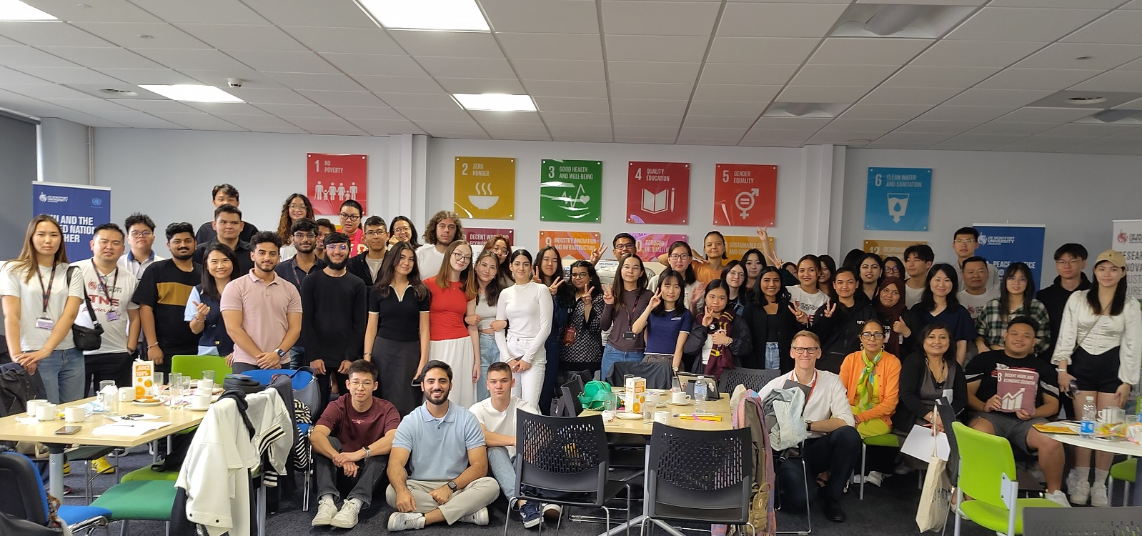

*DMU students taking part in the Carbon Literacy training June 2024*

# CONTRIBUTE

Opportunities to contribute are at the heart of the SDG Advocates scheme. Anything that helps make a difference to address sustainability and the UN Sustainable Development Goals (SDGs) counts – this might be organising an educational event, doing a volunteering activity with DMULocal, taking part in a structured project over many months (e.g., through the Enactus student society), or lobbying businesses or politicians to improve their policies and practices.

The only requirement is that this is linked to DMU in some way – for example organised by DMU, De Montfort Students Union (DSU), or a DSU Student Society, focussing on sustainability at DMU or inspired by your studies at the university. If you are not clear if something counts for the purposes of this scheme, just email [sustainability@dmu.ac.uk](mailto:sustainability@dmu.ac.uk)

## Pre-Organised Extra-Curricular Activities

There are several opportunities that are being organised this year at DMU that you could undertake as part of your Contribution. These include:

* Being a **Green Impact Project Assistant (GIPA)** – supporting staff teams to make changes to practices to better promote sustainability (training is provided)
* Being a **Green Impact Auditor** - checking that the staff teams participating in Green Impact have made the changes to the required standard (training is provided)
* Being a **Responsible Futures Auditor** – checking the university’s progress in embedding sustainability and the SDGs into teaching and learning at DMU (training is provided)
* **Volunteering** on the Hedgehog Friendly Campus initiative
* **Volunteering** on the student allotment project
* **Volunteering** with DMULocal, DSU or DMU Global
* Applying for a **SeeD Grant for SDGs** to run an activity, project, or event with others
* Reviewing your taught course and how it addresses sustainability using our **’10 Ingredients’ toolkit**
* Helping to deliver **Carbon Literacy Training in Leicester Schools**

To find details about the above opportunities, contact the DMU Sustainability team on [sustainability@dmu.ac.uk](mailto:sustainability@dmu.ac.uk) or post on the Advocates Teams group.

Any other one-off opportunities will be circulated around to the network via Teams and email so that Advocates can volunteer to take part.

## Self-Organised Extra-Curricular Activities

A key part of the SDG Advocates scheme is an encouragement for students to self-organise events and activities. This does not need be something you do alone – you can share ideas at networking events or online, get involved with student societies that are already doing projects or share your ideas with the sustainability team to see how we can offer support (email [sustainabilty@dmu.ac.uk](mailto:sustainabilty@dmu.ac.uk))

Activities also do not need be big! Think about how you can start small with the time and opportunities available to you to influence others and use your platform – as a DMU SDG Advocate you are actively encouraged to make your voice heard.

# RECOGNITION

The Advocates scheme aims to enable students to get recognition for taking part – this is something that can go on your CV and should be something to be proud of, representing your efforts to learn and make a difference during the year. The scheme will be an accredited activity for HEAR reports, and we also aim to be able to award a Digital Badge for participants, which can go on your LinkedIn profile, CV and more. The various aspects of recognition are described below.

## Your Learning and Contribution

To achieve your recognition, firstly you need to take part in Learning activities and spend time contributing. As a minimum we request that you take part in at least one of the Short Courses for advocates (attending or watching a 15-minute video and completing a short quiz at the end) and spend at least 1 hour contributing to an activity – this might be something organised by DMU or DSU or something you help make happen yourself.

You are of course actively encouraged to do more and use your available time and opportunities to have the best impact you can during your time as a SDG Advocate. One way of getting further recognition is through the Awards part of the end of year Celebration event.

## Your Reflection

To achieve your recognition, you also need to complete a short reflection on your experience over the year. This would describe what you learned and how you contributed and give you a chance to reflect on what you got out of the experience, how it shifted your understanding and what you would like to do next. Your reflection is not assessed like an essay or exam – it is simply your way of sharing what you did and having a chance to consider what you got out of it.

A form for reflections will be shared with SDG Advocates later in the academic year.

## Celebration and Awards

At the end of the academic year, the project will host a celebration event. This is a chance for members of the network to come together and see what others have achieved and to give recognition for unique or outstanding contributions.

# THE TEAM

These are some of the people you are likely to interact with this year as a Sustainability Advocate:

**Karl Letten**

*Sustainability Manager*

Karl’s role focusses on managing the sustainability of DMU’s campus operations, including reducing carbon emissions, promoting active travel, and engaging with students and staff to help more people to learn about sustainability. Outside of DMU, Karl enjoys walking his dog and tinkering with his vintage scooters.



**Mollie Lester**

*Student Sustainability Coordinator*

Mollie is a DMU Law student in her third year and is spending her placement year with the sustainability team looking at sustainable procurement and the carbon emissions associated with the products and services that the university buys. Mollie will also work on engaging DMU staff and students on sustainability activities and improving DMU’s sustainability performance across a range of different areas.

**Andrew Reeves**

*****Education for Sustainable Development Academic Lead*

Andrew co-ordinates DMU’s Education for Sustainable Development work, which aims to help students, staff and the wider community learn and act on sustainability. Andrew is an Associate Professor in DMU’s Institute of Energy and Sustainable Development, focussing on changing behaviour and social systems to address climate change. Outside of DMU, Andrew lives on a narrowboat with his partner on Leicester’s River Soar and is very occupied caring for a lively three-year old.

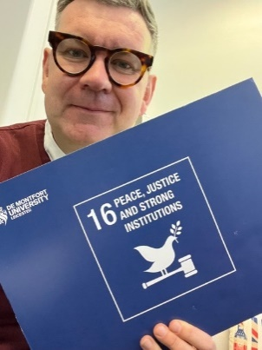**Mark Charlton**

*Associate Director of Public Engagement*

Mark leads the United Nations Academic Impact Hub for Sustainable Development Goal 16 at De Montfort University, the only UNAI hub in the UK which aims to engage people to work towards the targets and indicators of all the global goals with a particular focus on SDG 16: Peace, Justice, and Strong Institutions. Outside of DMU, Mark is a busy father of twins and founder member of the United Kingdom Hertha BSC fan club and hosts its regular podcast which shares the trials and tribulations of being an exiled Bundesliga football fan.

  
**Manjeet Ridon***Associate Dean International (Education, Sustainability & EDI)*

Manjeet is DMU’s institutional lead for sustainability in Transnational National Education (TNE) and leads on several sustainability related initiatives with TNE partners, supporting them in the development of sustainability strategies, staff training for carbon literacy, and sustainability projects aimed at raising awareness with staff and students, and engage with the UN SDGs to enhance and improve teaching and student learning, including volunteering in international communities and campaigning for global action on women’s empowerment and climate issues. Outside of DMU, Manjeet is a busy mum of three and loves reading fiction and dogwalking!

# FAQ

**Can I still join the scheme if I sign up late in the year?**

Yes – and if you meet all the criteria for Learning and Contribution and submit an end-of-year reflection, you can still get formal Recognition as an Advocate.

**Can I be a Sustainability Advocate again next year?**

Yes! Our intention (and hope) is that students can be a Sustainability Advocate for more than one year and achieve Recognition for every year in which they take part. Perhaps Advocates in their 2nd year (or 3rd year!) will play more of a leadership role, helping to run sessions or co-ordinate the network – that is for members of the network to decide!

**Can my taught course count as my ‘Learn’ activity?**

No – this scheme is to encourage and recognise activities that take place outside of taught programmes at DMU. However, you could still count (or help organise) a learning activity associated with a particular course – for example, an ‘Enactus Society’ entrepreneurship project would count, as this is voluntary activity, even if you are also studying Entrepreneurship.

**Does my ‘Contribute’ activity have to be done at DMU?**

We would expect this to be done either at DMU, locally or through a DMU-related project if done further afield (e.g., a DMU Global Trip). This might well be an opportunity offered by DMULocal, DSU Volunteering or the Sustainability Team, and if not, by a DMU Student Society. If it is none of these, then check with the project team about whether it can count – our aim is to support and promote any Contribution linked to your role within the DMU community.

If you have other questions not covered here, please post them on the Teams group or email [sustainability@dmu.ac.uk](mailto:sustainability@dmu.ac.uk)